

**College of Technological Innovation**

**Final Exam SWE 245 – Springer 2020**

**Prof. Ahmed Seffah**

**Name: Siem Zeresenay**

**ID: M80008217**

**Instructions**

Read carefully the following rules and policy before starting your exam.

* **You have 120 minutes maximum to complete this exam.**
* **You will receive a penalty of 10 points if you keep working after the instructor calls for submitting the papers and the blackboard system is closed.**
* **This exam is open-book. You have access to w3school.com and an HTML/CSS editor (Bracket and NotePad++) as well as all the material on the course blackboard pages.**
* **Searching elsewhere for solution is just wasting your time. This exam has been prepared for this class only. It has never been used elsewhere.**
* **When grading, if I detect that the work is not yours, meaning the code used is not related to your project or if there is any similarities with the work of other students, you final grade will be zero. A formal case of cheating will be initiated and submitted to Assistant Dean for further consideration.**
* **Answer all the questions. Each question is 20 points for total of 100 points. There is also a bonus question (5 points to be added to your final grade).**
* **All the questions are based on the project (your personal Website you have developed during the whole semester). Your answers should use the code your already developed in the project to which you need to add extra code to answer the questions. However, the code you add in RED.**
* **You should work on NotePad++ or Brackets and then extract the code (copy) and paste in this document after each question.**
* **At the end of exam, you should submit on blackboard two files. The first one is the exam (this document) in Word including your answers. The second one is a Zip file (your project) in which you add the code to answer the questions. Put the code you add or modify in RED in a way I can easily identify it.**
* **After submitting your exam on blackboard, check that the files you submitted are readable. If you submitted a file, I cannot open, you will get 0 (This is a passive form of cheating)**
* **If you are not able to submit your work for any reason. Stay connect on Adobe Connect and do not talk to anyone. I will assist you.**

**Question 1 (20 Points)**

During the entire semester, you have been working individually on the design and programming of a Web site. You have designed and created many pages, wrote several scripts in JavaScript and CSS as well as you implemented some of the popular patterns such as carousel, NavBar and collapsible menu.

The following are popular patterns for Web navigation. They are from wellie.com collection of Web design patterns, a well-known and widely used patterns (see their description from here, left side of this page (http://welie.com/patterns/showPattern.php?patternID=combined-menu)

1. Double Tab Navigation
2. Fly-out Menu
3. Map Navigator
4. Overlay Menu
5. Shortcut Box
6. Split Navigation
7. Teaser Menu

**Select one of these patterns that you think can apply for your site and explain why it can be applied for your site, when you applied it (which page of your site), which problem this pattern solves for your users and what are the consequences of applying this pattern. Formulate your answer in the format of bullet, be precise and concise.**

|  |  |
| --- | --- |
| 1. **Selected pattern name =** Fly-out Menu | |
| **Why** | * **Because the navigation bar in my website needs to include 11 webpages, so in order to hold all this links in the nav-bar, I need to make the reset of the pages accessible.** |
| **When** | * **I applied this pattern when the number of my pages started to increase and it was past 6 or 7, then I had the idea that I can make them in a collapsible mode.** * **I used this in my home page of my website.** |
| **Which** | **This patter solves the issue of:**   * **A user searching around the website to find one link to a page (Eg: the about/help page), instead of finding it in homepage of website.** * **Good format of navigation bar and easily accessible by just hovering over the link.** * **And we can put as many links as we want.** * **No need to click anything or reload the page as this takes time, instead hover.** |
| **What** | **The consequences are:**   * **Users will have quick access to menu items of the website.** * **Problems with selecting if the user leaves or miss the area where the hover works (even over small pixels).** * **You need to indicate that it is a dropdown menu.** * **We can only use horizontal menus with vertical fly-outs menus as the vertical area for the mouse to click is too small.** |
| **Provide the screenshot of the page from you site (where pattern can apply), show where you should put the pattern** |  |

**Question 2 (20 Points)**

I need to apply Fly-out menu here:

Discuss the cons and the pros of using the following technologies to implement the pattern you selected. Answers in the format of bullets (lists maximum 3 props and 3 cons for each technology)

|  |  |  |
| --- | --- | --- |
| Web Development Technology | Pros | Cons |
| 1- Only HTML | * The code will be contained in the page so direct access to the styling of elements and classes in the code. * No need to create any external files and link them to the page to implement the fly-out menu. | * Codes will be complicated as you will have to do the layout and styling inside html tags. * The styling codes will be hard to identify if you want to make some changes because all the styling codes are spread over all the page inside html tags. |
| 2- Only HTML + CSS | * With CSS we can contain all the layouts at the same time and use classes to use the layout constantly. * Organized documentation of the code with the necessary tags to implement the pattern in html and styling on a separate file which can be linked to the page and utilized. | * There might be struggle with assigning classes to style each single code and then use them in the CSS script. * Overlapping of class names, so there will be crashed in the page. * You will need to write and implement all the styles for the pattern by yourself. |
| 3- HTML + CSS + JavaScript | * Everything here including the html tags, codes and scripts will be precisely separated and we have more options to use. * we can implement the pattern either using CSS or JavaScript to show the dropdown. | * Pattern will take more effort to implement using only these technologies. * Issues with JavaScript codes and complication of the code. * Takes time for the page to load if we use JavaScript. |
| 4- Bootstrap + JavaScript | * We can make it responsive when used in small screen and larger screen. * Less effort needed to write the codes as we can just use ready-made from w3schools or bootstrap. | * Not being able to use CSS here might be a problem because we need to customize the pattern to fit in our pages. * We have to be careful if the appropriate library for bootstrap is not used, pattern won’t work. |
| 5- All the above + Web services | * This is best option as we can use bootstrap to get the code for the nav-bar and there are ready-made codes so we can copy and paste them in our pages. * We can make the patten responsive to be visible in smaller screen size. * We can use web services which we only need to customize the pattern as we like, generate the code and copy and paste to our page. | * If we use web service, it is limited by the website we used to get the pattern so we are restricted to that website which can be uncomfortable. * Using many web services can overload the browser while running your website, so the user can be frustrated with this issue. |

**Question 3 (20 Points)**

Write the CSS code that define the properties and styling of the pattern you selected. Properties incudes, but limited to this, colour, font size, background, etc. You should list 10 properties.

|  |  |
| --- | --- |
| Property |  |
| 1. Color | .dropdown-content a {  Color: black;  } |
| 1. Font size | .dropdown {  font-size: 17px;  } |
| 1. Background-color | .dropdown-content a:hover {  Background-color:lightgray;  } |
| 1. Text-align | .topnav a {  Text-align: center;  } |
| 1. Font-family for dropdown menu | .dropdown .dropbtn {  font-family:inherit;  } |
| 1. Padding for the link | .topnav a {  Padding: 10px 15px;  } |
| 1. Margin | .dropdown .dropbtn {  Margin: 3px;  } |
| 1. Float the pattern to the left. | .dropdown {  Float: left;  } |
| 1. No text-decorations for the navigation | .topnav a {  Text-decoration: none;  } |
| 1. Display the block of links when hovering | .dropdown:hover .dropdown-content {  Display:block;  } |

**Question 4 (20 Points)**

Draw a wireframe showing all the pages of your site (nodes are pages), put in the centre the page where the pattern you slected apply, and then show the links from the pattern to the other pages of your site.

*Note = You can draw the wireframe on a piece of paper, take a picture with you mobile and add the picture here.*

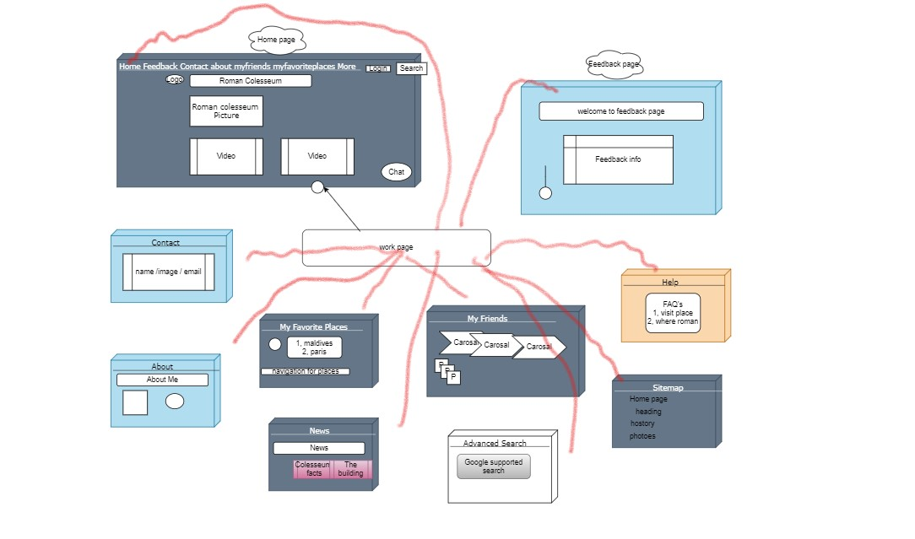

**Question 5 (20 Points)**

As part of your personal website, you already created a page that uses the NavBar to display your five favourite places to visit. Modify the code you already wrote in way when the use selects a place, it displays in the same page images (3-4 images) bout the place displayed in a Carousel. You are requested to provide here the portion of the code to implement this (No need to put the entire code of the HTML page).

<nav class="navbar navbar-expand-md bg-dark navbar-dark">

  <div class=" container-fluid">

    <ul class="nav navbar-nav">

      <button

        onclick='document.getElementById("first").style.display="block"';>

        <li><a href="https://en.wikipedia.org/wiki/Maldives" target="_blank">1. Maldives Island</a></li>

      </button>

      <button

        onclick="document.getElementById('second').style.display='block'";>

      <li><a href="https://en.wikipedia.org/wiki/Paris" target="_blank">2. Paris: Effil Tower</a></li>

    </button>

    <button

      onclick="document.getElementById('third').style.display='block'";>

      <li><a href="https://en.wikipedia.org/wiki/Rome" target="_blank">3. Roman Colosseum</a></li>

    </button>

    <button

      onclick="document.getElementById('fourth').style.display='block'";>

      <li><a href="https://en.wikipedia.org/wiki/Grand_Canyon" target="_blank">4. Grand Canyon</a></li>

    </button>

    <button

      onclick="document.getElementById('fifth').style.display='block'";>

      <li><a href="https://en.wikipedia.org/wiki/FC_Barcelona" target="_blank">5. Barcelona FC Studium</a></li>

    </button>

    </ul>

  </div>

</nav>

<div class="clod">

  <h3 style="text-align: center;"> I plan to visit this places in 2021 </h3>

  <div id="first" style="display: none;">

    <img src="images/hjde.jpg" alt="image">

      <img src="images/hjde.jpg" alt="image">

      <img src="images/hjde.jpg" alt="image">

  </div>

  <div id="second" style="display: none;">

    <img src="images/hjde.jpg" alt="image">

      <img src="images/hjde.jpg" alt="image">

      <img src="images/hjde.jpg" alt="image">

  </div>

  <div id="third" style="display: none;">

    <img src="images/hjde.jpg" alt="image">

      <img src="images/hjde.jpg" alt="image">

      <img src="images/hjde.jpg" alt="image">

  </div>

  <div id="fourth" style="display: none;">

    <img src="images/hjde.jpg" alt="image">

      <img src="images/hjde.jpg" alt="image">

      <img src="images/hjde.jpg" alt="iamge">

  </div>

  <div id="fifth" style="display: none;">

    <img src="images/hjde.jpg" alt="image">

      <img src="images/hjde.jpg" alt="image">

      <img src="images/hjde.jpg" alt="image">

  </div>

   </div>